API

🌐 What Is an API?
# Source: AI Source: Provided by: [Data Path: Persons Table -> ID Column: 1, Name_En Column: Motasem Essam] -> From: [ChatGPT] on [1/19/2026]
API stands for Application Programming Interface.

🧠 In Simple Terms:
# Source: AI Source: Provided by: [Data Path: Persons Table -> ID Column: 1, Name_En Column: Motasem Essam] -> From: [ChatGPT] on [1/19/2026]
API = A set of rules that lets different software programs talk to each other.
It defines how one program can request services or data from another and what responses it can expect.

✅ What APIs Do
# Source: AI Source: Provided by: [Data Path: Persons Table -> ID Column: 1, Name_En Column: Motasem Essam] -> From: [ChatGPT] on [1/19/2026]
- Allow apps, websites, and services to communicate and share data.
- Enable developers to use features of other software without knowing internal details.
- Power integrations between different systems (e.g., your app talking to Google Maps).

🔧 Example
# Source: AI Source: Provided by: [Data Path: Persons Table -> ID Column: 1, Name_En Column: Motasem Essam] -> From: [ChatGPT] on [1/19/2026]
- When you use a weather app, it might call a weather API to get the latest forecast.
- A payment gateway API lets an online store process credit card payments.

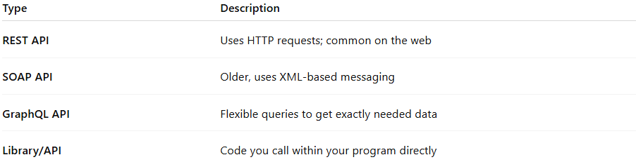

Type | Description
REST API | Uses HTTP requests; common on the web
SOAP API | Older, uses XML-based messaging
GraphQL API | Flexible queries to get exactly needed data
Library/API | Code you call within your program directly

consume an API
# Source: AI Source: Provided by: [Data Path: Persons Table -> ID Column: 1, Name_En Column: Motasem Essam] -> From: [ChatGPT] on [1/19/2026]
When we say “consume an API” in software development, it means that a program or application is using (calling) an API to get data or perform actions provided by another system.

Breaking it down:
- API (Application Programming Interface):
  - A set of rules that allows one software system to interact with another.
  - Example: A weather app can get weather data from a weather service API.
- Consume:
  - To use or request data from the API.
  - Your application “consumes” the API by sending requests and handling the responses.

Example:
Suppose there’s a weather API at https://api.weather.com:
- Request (consuming the API):
GET https://api.weather.com/current?city=Cairo
- Response:
{
"city": "Cairo",
"temperature": "35°C",
"condition": "Sunny"
}
Your app consumed the API by sending a request and using the returned data to display the weather.

Key Points:
- “Consuming an API” does not mean creating the API; it means using it.
- Can be done with different types: REST APIs, SOAP APIs, GraphQL, etc.
- Often involves sending requests (GET, POST, PUT, DELETE) and handling responses (usually JSON or XML).

Summary
# Source: AI Source: Provided by: [Data Path: Persons Table -> ID Column: 1, Name_En Column: Motasem Essam] -> From: [ChatGPT] on [1/19/2026]
An API is like a waiter taking your order (request) to the kitchen (server) and bringing back your food (response). It lets software talk and work together.

